Name: ________________________________ Date: ___________________________________

Class: _________________________________ Teacher: ___________________________________

# Math Mini Quiz 3

This Mini Quiz, we’re going to explore the math concepts that you’ve learned so far in this unit. This assignment should take you about **15 minutes**.

1) Below, there are two different datasets. One makes more sense to represent as a scatter plot and the other makes more sense to represent in a two-way table. In the Space below, decide which dataset should go with which type of chart and make that chart.

| ***Teacher ages and the salaries:***  Darcy is 29 years old makes $50,000; Vanessa is 33 years old makes $53,000; Rosa is 42 years old and makes $60,000; Jimmy is 24 years old: $41,000; Jenna is 22 years old makes $40,000; Fatima is 34 years old and makes $50,500; Joseph is 25 years old and makes $47,000; Maya is 39 years old and makes $59,000. |
| --- |
| ***Teacher dietary preferences and astrology signs***  Darcy is a vegetarian and a Scorpio; Vanessa has no dietary restrictions and is a Capricorn; Rosa is a vegetarian and a Capricorn; Jimmy is a vegetarian and a Ccorpio; Jenna has no dietary restrictions and is a Capricorn; Fatima has no dietary restrictions and is a Capricorn; Joseph is a vegetarian and a Scorpio; Maya is a vegetarian and a Capricorn. |

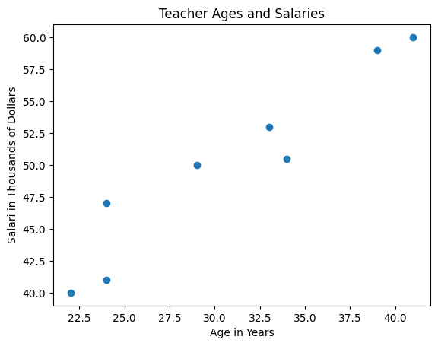

|  | No Dietary Restrictions | Vegetarian | Total |
| --- | --- | --- | --- |
| Capricorn | 3 | 3 | 6 |
| Scorpio | 0 | 2 | 2 |
| Total | 3 | 5 | 8 |

2) Why did you choose to make the charts the way you did?

*Teacher age and salary represents two numerical values (age and salary) for each data point (each teacher). Scatter plots are the best equipped for analyzing datasets with two values.*

*Teacher sign and diet on the other hand represents two categorical values (Scorpio/Capricorn and vegetarian/no). These types of data sets are best suited for two-way tables.*

3) Think of the correlation coefficient between teacher ages and salaries. Give a rough estimate of the value and explain why you chose it.

*The correlation coefficient should be: positive, and between 0.5 and 1.*

*We know it is positive because as age increases, so does the salary. We also know it should be closer to 1 because the correlation seems strong. The points move up at what seems to be a pretty consistent rate, looking roughly like a straight line.*

4) (a) Of the Scorpios, what percentage are vegetarians? (b) Of the Capricorns, what percentage are vegetarians? (c ) Are there more Scorpio vegetarians or more Capricorn Vegetarians? Is a higher percentage of Scorpios or Capricorns vegetarian? (d) Of the total population, what percentage is vegetarian?

*(a)* Vegetarian Scorpios / Total Scorpios = 2 / 2 = 100%

*(b)* Vegetarian Capricorns / Total Capricorns = 3 / 6 = 50%

*(c ) There are 3 Capricorn vegetarians and 2 Scorpio vegetarians, so there are more Capricorn vegetarians. However, 100% of Scorpios are vegetarians while 50% of Capricorns are, meaning there’s a higher* ***percentage*** *of Scorpios who are vegetarians.*

(d) Total Vegetarians / Total number of people = 5 / 8 = 62.5%